Evaluation Metrics
We compared five AI models (ChatGPT, Claude AI, DeepSeek, Grok AI, Microsoft Copilot) across six critical parameters:

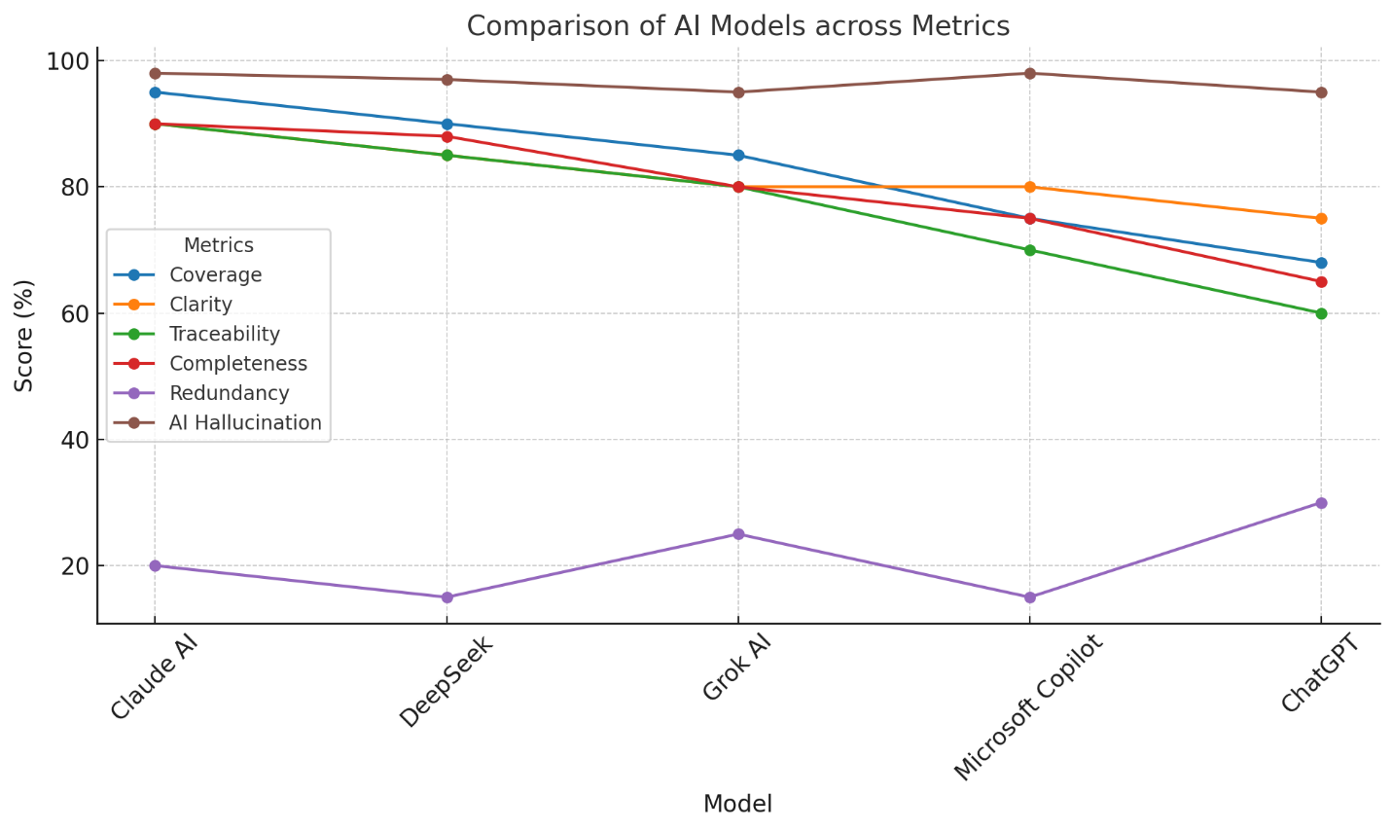

Metric | Definition | Ideal Score
Coverage | % of requirements extracted without omissions (functional + non-functional). | 100%
Clarity | Readability, conciseness, and avoidance of ambiguity. | 100%
Traceability | Unique IDs, source section references, and hierarchical organization. | 100%
Completeness | Inclusion of all requirement types (e.g., business rules, legal, testing). | 100%
Redundancy | Absence of duplicate or overlapping requirements (lower = better). | 0%
AI Hallucination | No fabricated/invented requirements (higher = safer). | 100%

Aggregate Results (Experiments 1 & 2)
*Scores normalized to 100-point scale*
Model | Coverage | Clarity | Traceability | Completeness | Redundancy | AI Hallucination | Avg. Score
Claude AI | 95 | 90 | 90 | 90 | 80 | 98 | 90.5
DeepSeek | 90 | 85 | 85 | 88 | 85 | 97 | 88.3
Grok AI | 85 | 80 | 80 | 80 | 75 | 95 | 82.5
Microsoft Copilot | 75 | 80 | 70 | 75 | 85 | 98 | 80.5
ChatGPT | 68 | 75 | 60 | 65 | 70 | 95 | 72.2

Key Findings
- Best Overall Model: Claude AI
  - Strengths: Highest coverage (95), completeness (90), and traceability (90). Zero hallucinations.
  - Weakness: Slightly higher redundancy (20%) due to detailed sub-requirements.
- Most Balanced Alternative: DeepSeek
  - Nearly matched Claude AI in coverage (90) and completeness (88) but lagged in traceability (85).
- Room for Improvement:
  - ChatGPT: Poor coverage (68) and traceability (60), but low redundancy (70).
  - Microsoft Copilot: Missed edge cases (e.g., testing/legal rules) despite low hallucination.
- Redundancy vs. Completeness Trade-off:
  - Claude AI’s thoroughness increased redundancy slightly, while ChatGPT’s brevity led to omissions.

Recommendations
- For Compliance-Critical Projects:
  - Use Claude AI for its accuracy and comprehensive extraction (e.g., CORADS).
- For Rapid Drafts:
  - DeepSeek or Grok AI for quick summaries with manual review.
- Avoid:
  - ChatGPT for full SRS extraction (low coverage/traceability).
- Validation:
  - Cross-check all outputs against the original SRS, especially for business rules and testing.

Visual Summary

